**Groovy Project**

**STRINGS**

**String in Groovy**

**A string is a sequence of characters. Generally, a string is a data type and implemented as an array of bytes which stores sequence of characters. In Groovy, String class is available in java.lang.String objects as well as in groovy.lang. GString which is called interpolated strings in some programming language.**

**Single quoted strings**

**Example 1:**

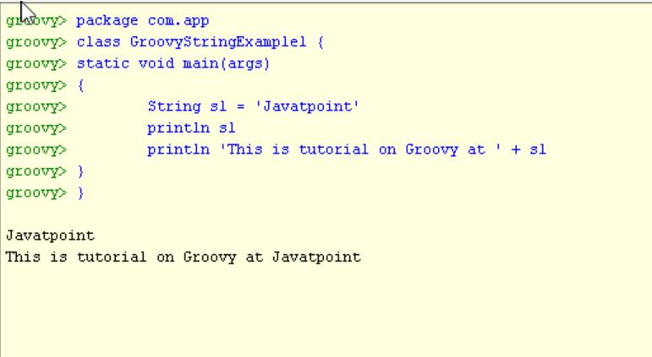

**Double quoted strings:**

**In groovy, Double-quoted string is a sequence of characters which is enclosed under double quotes.**

**Example 2:**

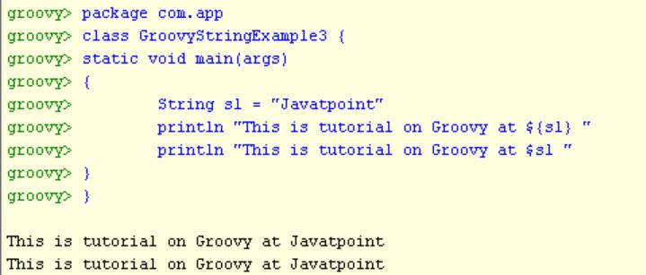

**T*riple*** **quoted strings:**

In groovy, Triple-single-quoted string is a sequence of characters which is enclosed under triple single quotes.

Example 4:

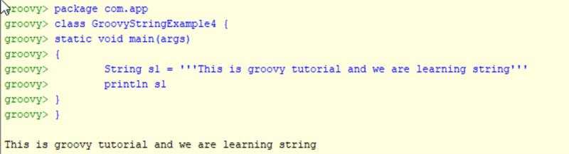

Example 5:

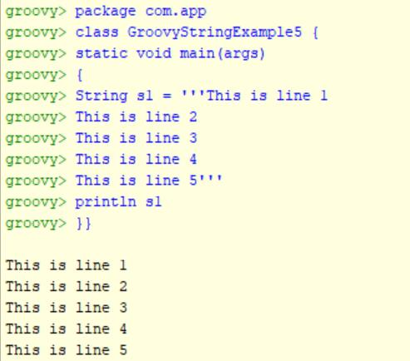

Example 6:

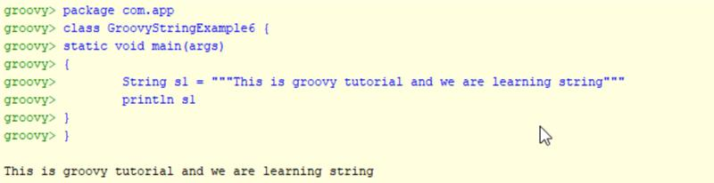

Example 7:

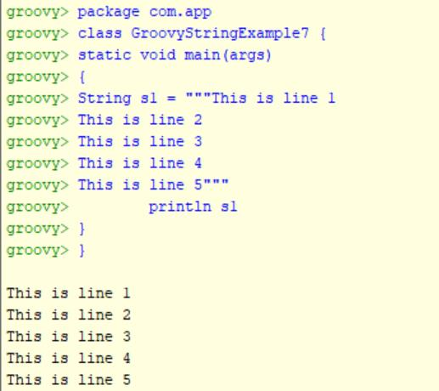

Example 8:

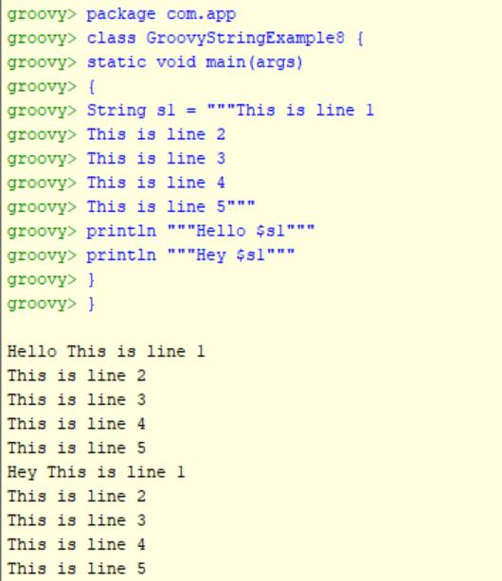

**Slashy string**

In groovy, slashy string is a sequence of characters which is enclosed in / forward slash. Slashy strings are useful for defining regular expressions and patterns where there is no need to escape backslashes.

Example 9:

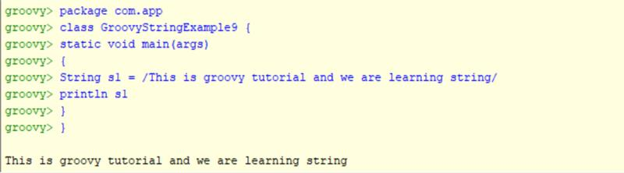

Example 10:

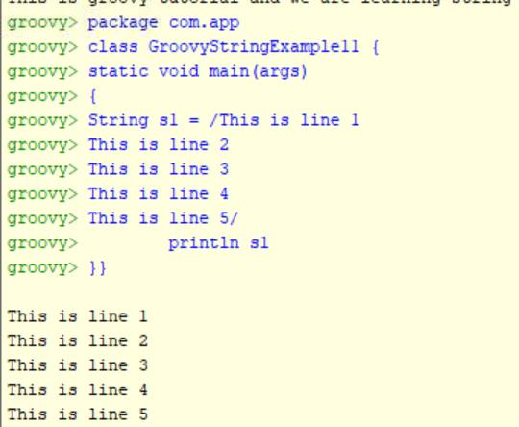

Example 11:

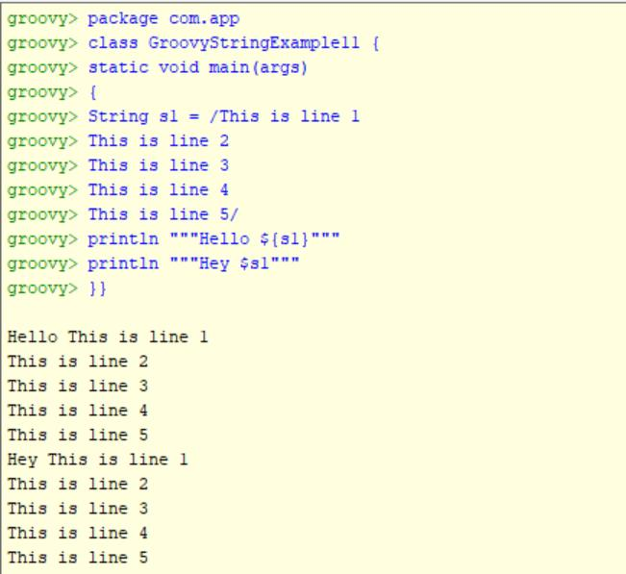

**DECISION MAKING:**

**Decision Making in Groovy**

In groovy, decision-making is used to check the condition and execute the statements. if the condition is true then the true block statement is executed and if the condition is false then the false block is executed.

1. **IF Statement:**

Example 1:

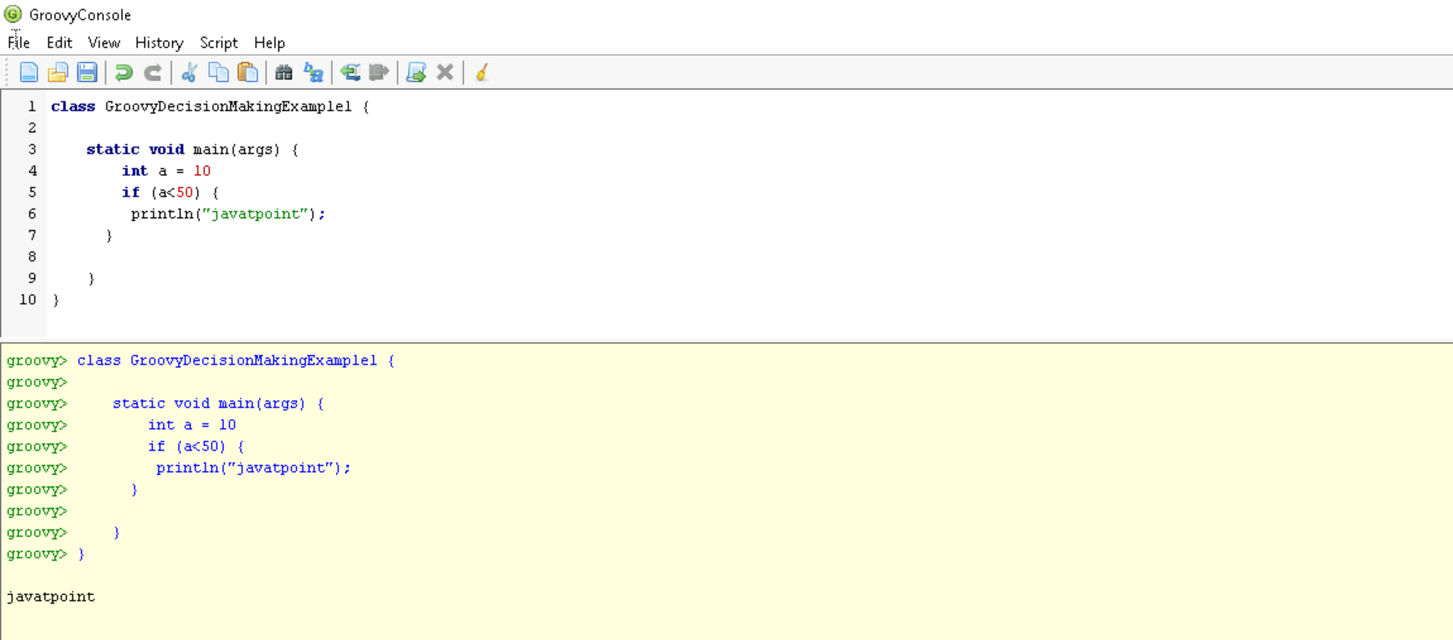

1. **IF- ELSE:**

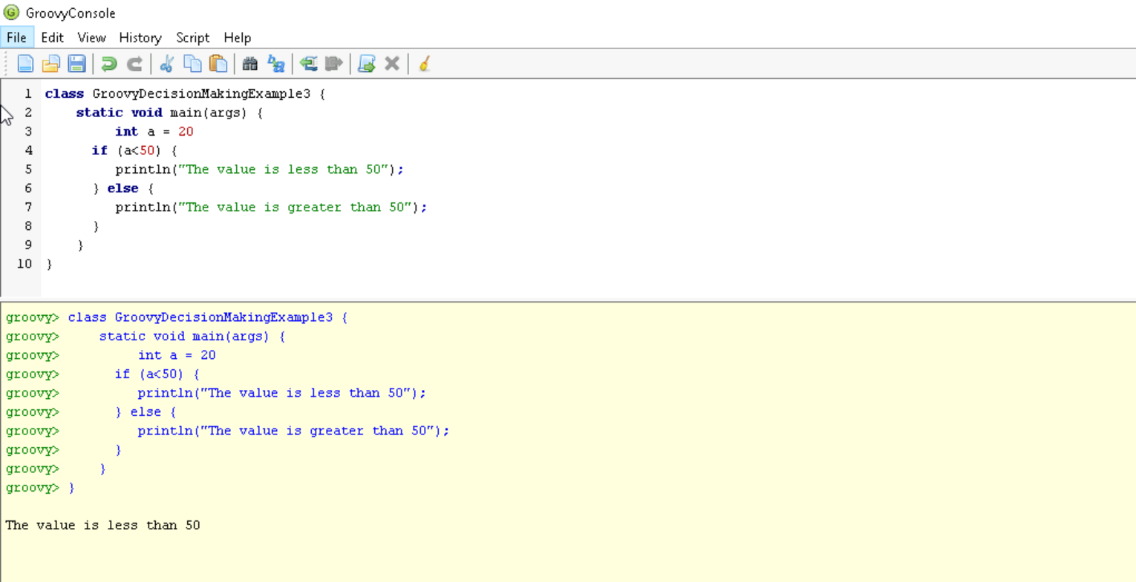

**3.NESTED – IF:**

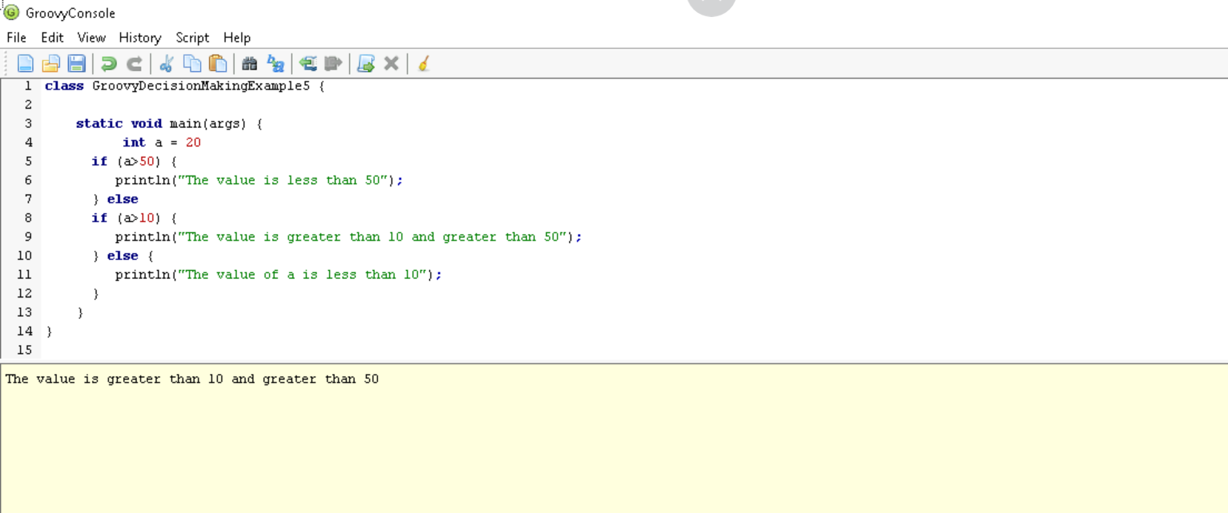

**4. SWITCH STATEMENTS:**

